PRACTICAL 8(2520090097)

- Develop a program using malloc(), calloc(), realloc(), and free(). Monitor memory allocation behavior and identify memory leaks using Valgrind.

Develop a program that demonstrates Copy-on-Write behavior after a fork(). Analyze memory usage before and after modifying data in the child process.

GNU
if (a == NULL) return 1;
printf("malloc: 5 integers allocated\n");

for (int i = 0; i < 5; i++)
a[i] = i + 1;

b = calloc(5, sizeof(int));
if (b == NULL) {
free(a);
return 1;
}
printf("calloc: 5 integers allocated and initialized to zero\n");

a = realloc(a, 10 * sizeof(int));
if (a == NULL) {
free(b);
return 1;
}
printf("realloc: memory increased from 5 to 10 integers\n");

for (int i = 5; i < 10; i++)
a[i] = i + 1;

temp = malloc(100 * sizeof(int));
printf("malloc: extra memory allocated\n");

free(a);
printf("free: first memory block released\n");

free(b);
printf("free: second memory block released\n");

printf("Program completed.\n");

return 0;
}
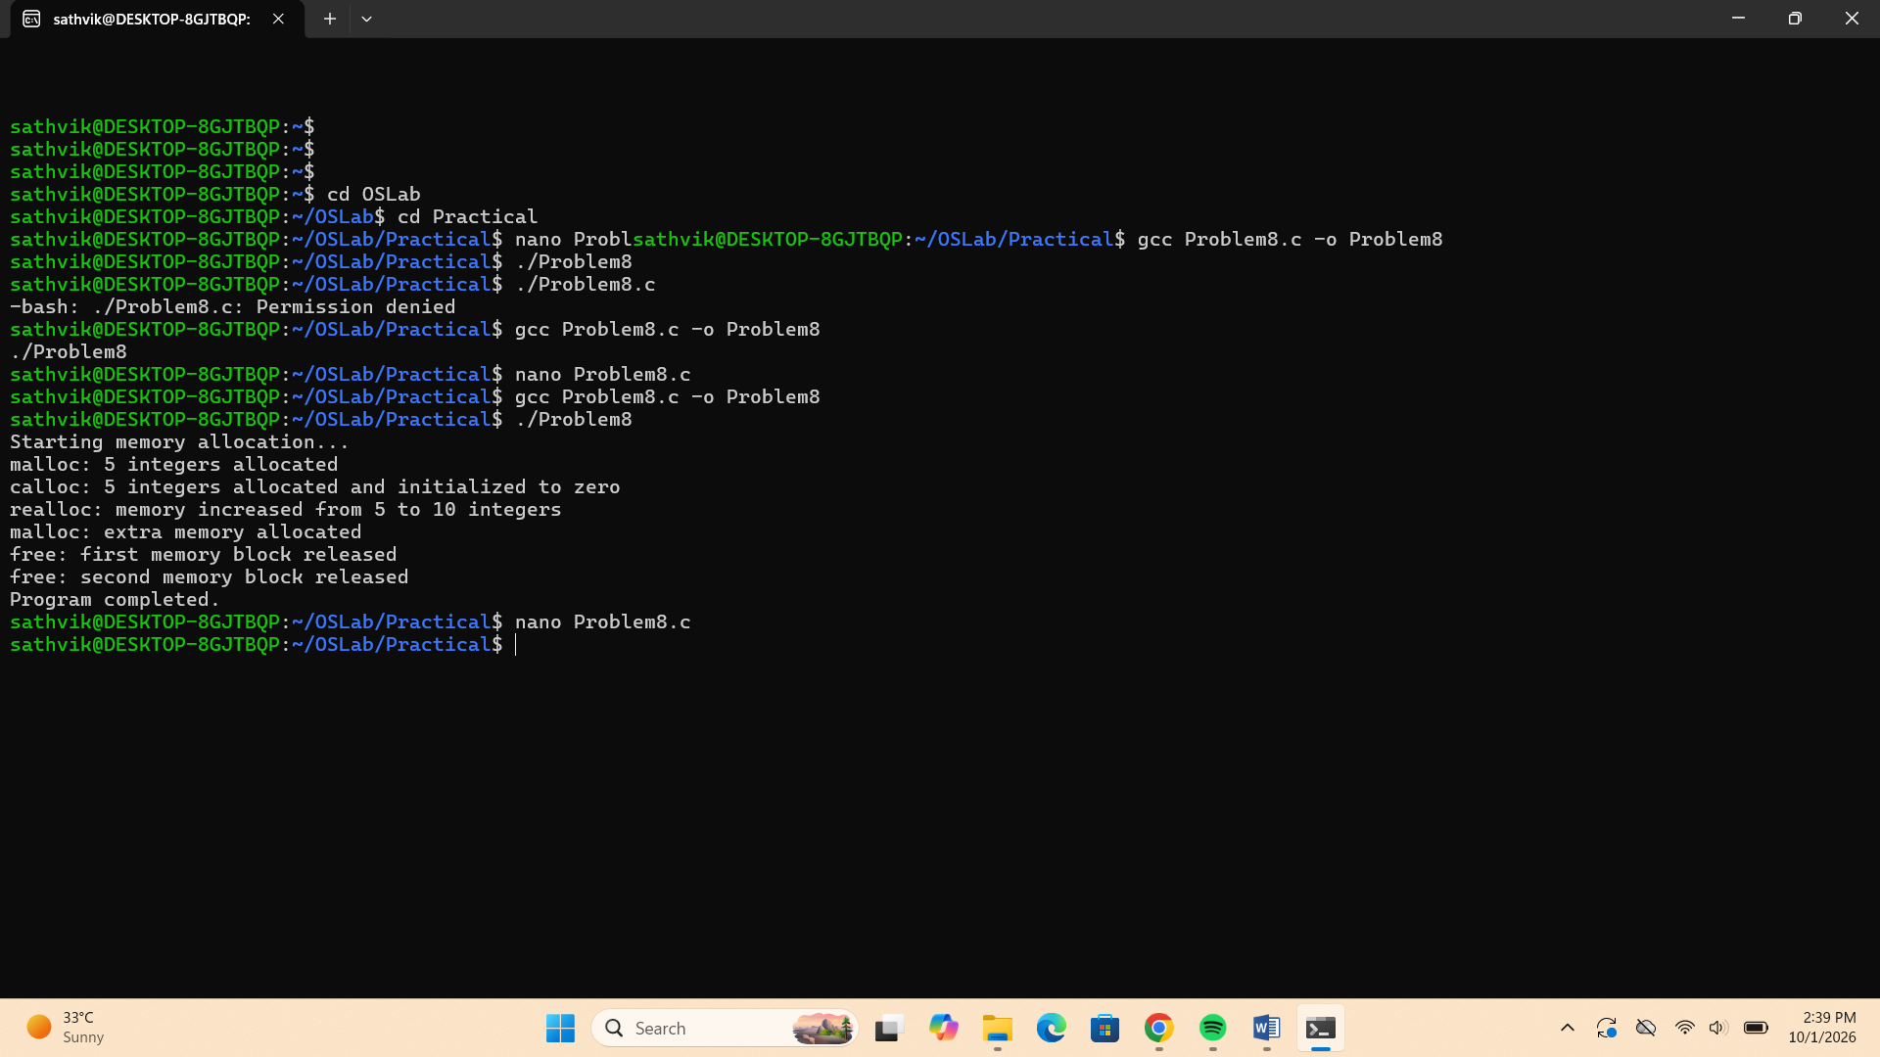

8b) #include <stdio.h>
#include <stdlib.h>
#include <unistd.h>
#include <sys/wait.h>

#define SIZE 1000000

int main() {
int *arr = malloc(SIZE * sizeof(int));

if (arr == NULL) {
perror("malloc");
return 1;
}

for (int i = 0; i < SIZE; i++)
arr[i] = i;

printf("=== Parent Process ===\n");
printf("Parent PID: %d\n", getpid());
printf("Memory allocated: %lu bytes\n",
(unsigned long)(SIZE * sizeof(int)));
printf("Initial arr[0] = %d\n", arr[0]);

fflush(stdout);

pid_t pid = fork();

if (pid < 0) {
perror("fork");
free(arr);
return 1;
}

if (pid == 0) {
printf("\n=== Child Process ===\n");
printf("Child PID: %d\n", getpid());
printf("Before modification: arr[0] = %d\n", arr[0]);

arr[0] = 9999;

printf("After modification: arr[0] = %d\n", arr[0]);
printf("Child has its own copy of the modified memory page.\n");

fflush(stdout);
free(arr);
exit(0);
}
else {
wait(NULL);

printf("\n=== Parent Process After Child ===\n");
printf("Parent PID: %d\n", getpid());
printf("Parent arr[0] = %d\n", arr[0]);
printf("Parent data remains unchanged.\n");

fflush(stdout);
free(arr);
}

return 0;
}
